Lab 4: Probability and Statistics with Python

Objective:
-We will be using the concepts from probability to perform machine learning related tasks
Tasks:
-Probability distribution using python's standard library
-Statistical hypothesis testing
-Bayesian statistics introduction with pymc3
Prerequisites:
Do the courses:
-Artificial Intelligence, Python Programming for Machine Learning & Deep Learning
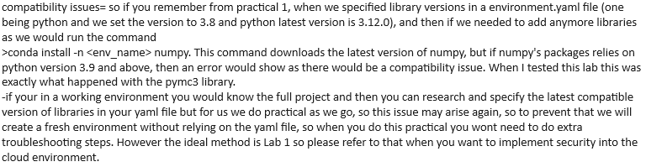
#create a new environment, please run these commands one by one
>conda create --name ml_env
>conda install -n ml_env pymc3
>conda install -n ml_env matplotlib
>conda install -n ml_env numpy
>conda install -n ml_env scipy
>conda install -n ml_env jupyter
>jupyter notebook

Task 1: Probability Distributions using Python's Standard Library
-This step involves understanding & working with probability distributions, such as the normal distribution.
import numpy as np
import matplotlib.pyplot as plt
# Generate samples from a normal distribution
mean = 0
std_dev = 1
num_samples = 1000
samples = np.random.normal(mean, std_dev, num_samples)
# Plot histogram of the samples
plt.hist(samples, bins=30, density=True, alpha=0.5, color='blue')
plt.title('Normal Distribution')
plt.xlabel('Value')
plt.ylabel('Probability Density')
plt.show()

Task 2: Statistical Hypothesis Testing
-we will compare 2 data samples using ttest and see if they are similar. We will use this as our null hypothesis, so “ data_group1 & data_group2 are similar”, if the p value is less than 0.05 we reject this hypothesis.
from scipy.stats import ttest_ind
# Generate two sets of sample data
data_group1 = np.random.normal(0, 1, 100)
data_group2 = np.random.normal(1, 1, 100)
# Perform independent t-test
t_stat, p_value = ttest_ind(data_group1, data_group2)
print(f'T-statistic: {t_stat}')
print(f'P-value: {p_value}')
# Interpret the results
if p_value < 0.05:
print('Reject the null hypothesis')
else:
print('Fail to reject the null hypothesis')

Task 3: Bayesian Statistics Introduction with PyMC3
-Generate a data set and then create a Bayesian model using PyMC3 to describe the underlying distribution of the data, and then we will visualize the output.
import pymc3 as pm
import arviz as az
# Generate some data
data = np.random.normal(2, 1, 100)
# Create a PyMC3 model
with pm.Model() as model:
mu = pm.Normal('mu', mu=0, sigma=10)
sigma = pm.HalfNormal('sigma', sigma=1)
obs = pm.Normal('obs', mu=mu, sigma=sigma, observed=data)
# Perform Bayesian inference
with model:
trace = pm.sample(2000, tune=1000)
# Visualize the results
az.plot_posterior(trace, var_names=['mu', 'sigma'])
plt.show()

Conclusion-
By following these tasks we used concepts from probability to perform analytical tasks with Machine learning.

